Sequence Diagrams

Contents

[Create Employee (By Dean) 2](#_Toc481254424)

[Delete Employee (By Dean) 3](#_Toc481254425)

[Edit Employee (By Dean) 3](#_Toc481254426)

[Login (By Mahtarr) 4](#_Toc481254427)

[Order New Stock (By Mahtarr) 4](#_Toc481254428)

[Check Stock (By Mahtarr) 5](#_Toc481254429)

[Create Supplier (By Dan) 5](#_Toc481254430)

[Delete Supplier (By Dan) 6](#_Toc481254431)

[Edit Supplier (By Dan) 6](#_Toc481254432)

[Create Client (By Dan) 7](#_Toc481254433)

[Edit Client (By Dan) 7](#_Toc481254434)

[Delete Client (By Dan) 8](#_Toc481254435)

[Get delivery status (By Fraser) 8](#_Toc481254436)

[Check available (By Fraser) 9](#_Toc481254437)

[Type of work completed (By Fraser) 9](#_Toc481254438)

## Create Employee (By Dean)

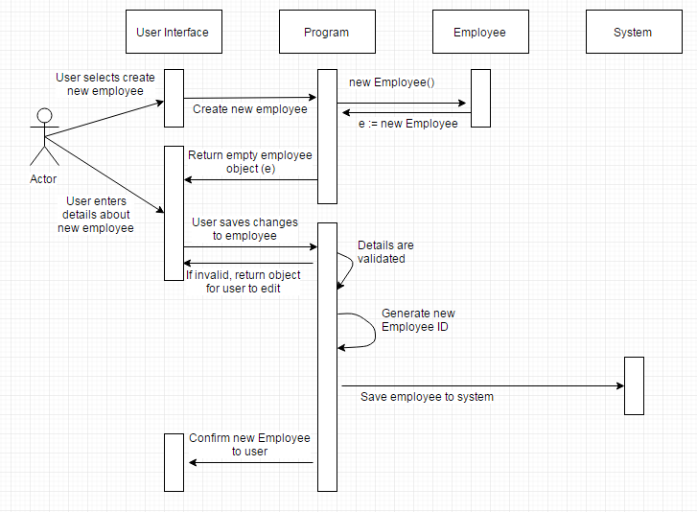

## Delete Employee (By Dean)

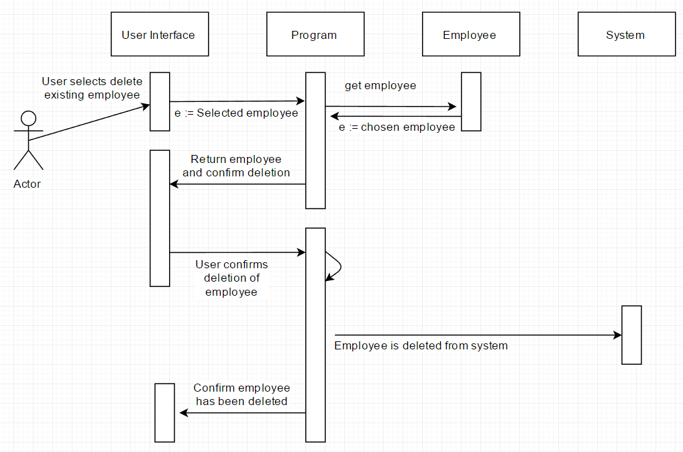

## Edit Employee (By Dean)

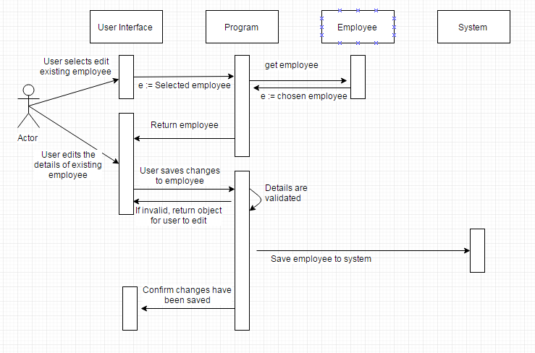

## Login (By Mahtarr)

C:\Users\FraserGamingPC\AppData\Local\Microsoft\Windows\INetCache\Content.Word\Login.png

## Order New Stock (By Mahtarr)

C:\Users\FraserGamingPC\AppData\Local\Microsoft\Windows\INetCache\Content.Word\order_new_stock.png

## Check Stock (By Mahtarr)

C:\Users\FraserGamingPC\AppData\Local\Microsoft\Windows\INetCache\Content.Word\checking_stock.png

## Create Supplier (By Dan)C:\Users\FraserGamingPC\AppData\Local\Microsoft\Windows\INetCache\Content.Word\Create_supplierSeq2.png

## Delete Supplier (By Dan)C:\Users\FraserGamingPC\AppData\Local\Microsoft\Windows\INetCache\Content.Word\Delete_supplierSeq.png

## Edit Supplier (By Dan)

C:\Users\FraserGamingPC\AppData\Local\Microsoft\Windows\INetCache\Content.Word\Edit_supplierSeq2.png

## Create Client (By Dan)

C:\Users\FraserGamingPC\AppData\Local\Microsoft\Windows\INetCache\Content.Word\Create_clientSeq.png

## Edit Client (By Dan)

C:\Users\FraserGamingPC\AppData\Local\Microsoft\Windows\INetCache\Content.Word\Edit_clientSeq.png

## Delete Client (By Dan)

C:\Users\FraserGamingPC\AppData\Local\Microsoft\Windows\INetCache\Content.Word\Delete_clientSeq.png

## C:\Users\FraserGamingPC\AppData\Local\Microsoft\Windows\INetCache\Content.Word\1.getdelivery.pngGet delivery status (By Fraser)

## C:\Users\FraserGamingPC\AppData\Local\Microsoft\Windows\INetCache\Content.Word\2.checkavailableemployees.pngCheck available (By Fraser)

## C:\Users\FraserGamingPC\AppData\Local\Microsoft\Windows\INetCache\Content.Word\3.typeofworkcompleted.pngType of work completed (By Fraser)